H.T No
Regulations:
A20

Sreenidhi Institute of Science and Technology
(An Autonomous Institution)
Code No: 8HC11 Date: 14-Mar-2023 (AN)

B.Tech I-Year II- Semester External Examination, March/April-2023 (Supplementary)
ADVANCED CALCULUS AND COMPLEX VARIABLES (EEE and ECE)

Time: 3 Hours Max.Marks:70

Note: a) No additional answer sheets will be provided.
b) All sub-parts of a question must be answered at one place only, otherwise it will not be valued.
c) Missing data can be assumed suitably.
Bloom's Cognitive Levels of Learning (BCLL)

Remember | L1 | Apply | L3 | Evaluate | L5
Understand | L2 | Analyze | L4 | Create | L6

Part - A Max.Marks:20

Answer all QUESTIONS.

 |  | BCLL | CO(s) | Marks
1 | Find the Integral factor 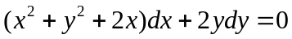 | L2 | CO1 | [2M]
2 | Solve (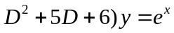 | L2 | CO2 | [2M]
3 | Evaluate 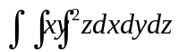where limits x=1 to 2, y=2 to 3 , z=3 to 4 | L3 | CO3 | [2M]
4 | State gauss Divergence theorem | L2 | CO4 | [2M]
5 | Define Rotational and Magnification of Conformal Mapping. | L2 | CO5 | [2M]
6 | State Cauchy Residue Theorem | L2 | CO6 | [2M]
7 | Solve 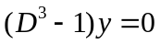 | L3 | CO2 | [2M]
8 | Evaluate 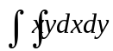 , where limits x=0 to 1, y=0 to x | L3 | CO3 | [2M]
9 | Define surface Integral | L2 | CO5 | [2M]
10 | Define essential singularity with an example. | L2 | CO6 | [2M]

Part – B Max.Marks:50
ANSWER ANY FIVE QUESTIONS. EACH QUESTION CARRIES 10 MARKS.

 |  |  | BCLL | CO(s) | Marks
11. | a) | Solve 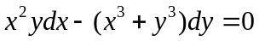 | L3 | CO1 | [5M]
 | b) | Solve x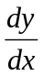 +y=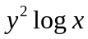 | L4 | CO1 | [5M]
12. | a) | Solve (D+4)y = tan2x | L3 | CO2 | [5M]
 | b) | (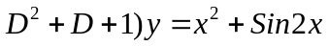 | L3 | CO2 | [5M]
13. | a) | Evaluate 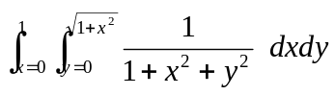 | L4 | CO3 | [5M]
 | b) | Find the 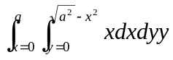 | L2 | CO3 | [5M]
14. |  | Evaluate 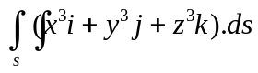 where “s” is the surface of the Sphere 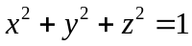 | L4 | CO4 | [10M]
15. | a) | State and prove C-R equations in polar form | L3 | CO5 | [5M]
 | b) | Show that the function U=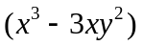is harmonic and find its corresponding Analytic function. | L3 | CO5 | [5M]
16. | a) | Evaluate 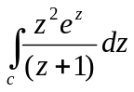 where C: |z|=2 | L3 | CO6 | [5M]
 | b) | Find the bilinear transformation that maps the point z₁=∞, z₂=i z₃=0 in to the point w₁=0 w₂=I and w₃=∞. | L4 | CO6 | [5M]
17. | a) | Find the orthogonal trajectories of family of Co=axial circles 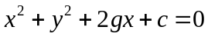 whee g is the parameter | L3 | CO1 | [4M]
 | b) | Solve (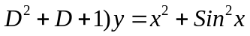 | L3 | CO2 | [3M]
 | c) | Solve 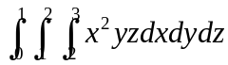 | L2 | CO3 | [3M]
18. | a) | State and give Geometrical interpretation for CurlF and Divergence F, Where F is the Vector. | L3 | CO4 | [4M]
 | b) | Determine the analyticity of f(z)=Sinz | L3 | CO5 | [3M]
 | c) | Expand f(z) =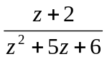 |  | CO6 | [3M]

-- 00 -- 00 –

